

October 05, 2024

**Financial assessment of USA share markets’ company**

**Submitted to**

Md. Erfan

Assistant Professor

Department of Computer Science & Engineering

University of Barishal

**Submitted by**

Ashraful Siddique

ID: 01

Batch: CF 24

Computer Fundamentals and Office application

Department of Finance and Banking

University of Barishal

**Date of Submission:**05/10/2024

# **Letter of Transmittal**

05 October, 2024

To,

Md. Erfan

Assistant Professor

Dept. of Computer Science & Engineering

University of Barishal

**Subject: Financial assessment of USA share markets’ company**

Sir,

We are pleased to submit our report on “**Financial assessment of USA share markets’ company**”. This is submitted under the requirement of Computer Fundamentals and Office program.

The report has been prepared in accordance with the observing knowledge that we have gathered during our observation period and your guidelines have been followed every aspect of preparing this report. We have really enjoyed working on this report and we hope that our work would meet the level of expectation.

We have tried to make this report precise the prime focus the report is to give a clear concept of “Financial assessment of USA share market”. However, we will always be ready to provide any further clarification that you may require.

Hope that you would be very pleased to aspect our report and oblige thereby.

Sincerely yours,

Ashraful Siddique

ID: 01

Batch: CF 24

Computer Fundamentals and Office application

Department of Finance and Banking.

University of Barisal.

# **Acknowledgement**

First of all, we would like to express our gratitude to almighty Allah for enabling us to complete this report on **Financial assessment of USA share markets’ company**. Successfully completion of any type of report requires help from a number of references. We have also taken help from different references for the preparation of the report. Now there is a little effort to show our deep gratitude to that helpful person. We convey our sincere gratitude to our course instructor Md. Erfan, Assistant professor of department of Computer Science & Engineering, University of Barishal. Without his kind direction and proper guidance this study would have been a little success. In every phase of the report, his supervision and guidance shaped this report to be completed perfectly.

# **Executive summary:**

This report provides a comprehensive analysis of the financial performance and trends of publicly traded companies in the United States. By examining key financial metrics and comparing them across industries and time periods, the report offers valuable insights for investors, analysts, and policymakers.

**Key findings include:**

* **Strong financial health:** The majority of US companies demonstrated solid financial performance, with increasing profitability and stable balance sheets.
* **Sector variations:** Technology and healthcare sectors outperformed other industries in terms of growth and profitability.
* **Rising debt levels:** The overall debt levels of US companies increased, reflecting a reliance on debt financing.
* **Growing mergers and acquisitions:** M&A activity remained robust, indicating a consolidation trend in certain industries.
* **Risk and return profile:** Investments in US stocks offered attractive returns, but investors needed to carefully consider risk factors such as market volatility and economic uncertainty.

Overall, the US share markets continue to be a dynamic and attractive investment environment, offering opportunities for both growth and diversification. However, investors should conduct thorough due diligence and consider their individual risk tolerance before making investment decisions.

Contents

**Letter of Transmittal** 2

**Acknowledgement** 3

**Executive summary:** 4

**1. Introduction** 6

1.2 Origin of the Report: 6

1.3 Objective of this study: 6

1.4 Methodology of the report 6

1.5 Data collection method 7

**2. PivotTable** 8

About PivotTable 8

Analyzing the Questions for PivotTable Research 10

**General Questions** 10

**Year-Specific Questions** 10

**Company-Specific Questions** 10

**2. Researchable Questions and Answer** 11

**Recommendation and Conclusion** 22

**Reference list** 23

# **1. Introduction**

The United States has long been a dominant force in the global financial markets, and its stock markets have been a primary driver of economic growth and investment opportunities. This report aims to provide a comprehensive financial assessment of publicly traded companies in the US share markets. By analysing key financial metrics and trends, we seek to offer valuable insights for investors, analysts, and policymakers.

## 1.2 Origin of the Report:

This report was initiated in response to the growing interest in understanding the financial health and performance of US companies. As the global economy becomes increasingly interconnected, the US stock markets play a pivotal role in shaping global financial conditions. This report is designed to provide a thorough examination of the financial landscape of US companies, enabling informed decision-making.

## 1.3 Objective of this study:

**The primary objectives of this study are:**

* To assess the overall financial health of US publicly traded companies.
* To identify key financial trends and patterns within the US share markets.
* To analyze the performance of different industry sectors and company sizes.
* To evaluate the risk and return profile of investments in US stocks.
* To provide insights for investors, analysts, and policymakers.

## 1.4 Methodology of the report

This report employs a quantitative research methodology, relying on financial data collected from publicly available sources. The analysis will be based on a combination of financial ratios, statistical techniques, and industry benchmarks.

## 1.5 Data collection method

The following data sources will be used:

* **Financial statements:** Income statements, balance sheets, and cash flow statements of publicly traded US companies.
* **Market data:** Stock prices, trading volumes, and market capitalization from financial databases.
* **Industry reports:** Research reports and analyses published by industry experts.
* **Economic indicators:** Macroeconomic data such as GDP, inflation, and interest rates.

By combining these data sources, we will be able to construct a comprehensive picture of the financial performance and risk profile of US companies.

# **2. PivotTable**



# About PivotTable

PivotTables are a versatile feature in spreadsheet software like Microsoft Excel or Google Sheets that allow you to summarize and analyse large datasets quickly and efficiently. They enable you to rearrange and group data in different ways, creating dynamic tables that can be easily updated as your data changes.

**Key Features and Benefits of PivotTables:**

**Data Aggregation:** PivotTables can summarize data using various functions, such as sum, average, count, maximum, and minimum.

**Grouping and Filtering:** You can group data by categories (e.g., years, regions, products) and filter results to focus on specific subsets.

**Dynamic Updates:** PivotTables automatically adjust as you add or modify data, providing real-time insights.

**Customization:** You can customize the appearance and layout of PivotTables to suit your specific needs.

**Multiple Levels:** PivotTables can handle multiple levels of grouping, allowing you to analyze data at different granularities.

**Common Use Cases for PivotTables:**

**Financial Analysis:** Analysing sales trends, profitability, and financial ratios.

**Market Research:** Understanding customer demographics, product preferences, and market trends.

**Sales Performance:** Evaluating sales team performance, territory analysis, and customer segmentation.

**Operational Efficiency:** Tracking inventory levels, production costs, and delivery times.

**Quality Control:** Monitoring product defects, customer satisfaction, and process performance.

**Creating a PivotTable:**

1. Select your data: Highlight the range of cells containing the data you want to analyze.
2. Insert a PivotTable: Go to the "Insert" tab and choose "PivotTable."
3. Choose a location: Select where you want the PivotTable to appear.
4. Drag fields: Drag fields from the "Fields" area to the "Rows," "Columns," and "Values" areas to create your PivotTable.
5. Customize: Adjust the PivotTable's appearance and functionality using the "PivotTable Tools" tab.

# **2. Researchable Questions and Answer**

|  |  |  |  |  |
| --- | --- | --- | --- | --- |
| 1. What is the "Ticker Symbol" for the company with the highest "Total Revenue" in 2014? | | | | |
| 1. Which company had the lowest "Earnings Per Share" in 2015? | |  |  |  |
| 1. How has the "Accounts Payable" for the company AAL changed from 2012 to 2015? | | | |  |
| 1. What was the "Capital Expenditures" for AAP in 2012 and how does it compare to 2015? | | | | |
| 1. Which company had the highest "After Tax ROE" in 2013? | |  |  |  |
| 1. In which year did AAL have the largest "Total Liabilities"? | |  |  |  |
| 1. How did the "Total Current Assets" for AAP change between 2012 and 2013? | | | |  |
| 1. Which company reported the lowest "Cash Ratio" in 2014? | |  |  |  |
| 1. What is the difference between "Accounts Receivable" and "Accounts Payable" for AAL in 2015? | | | | |
| 1. Which year saw the highest "Capital Surplus" for AAL? |  |  |  |  |

**What is the "Ticker Symbol" for the company with the highest "Total Revenue" in 2014?**

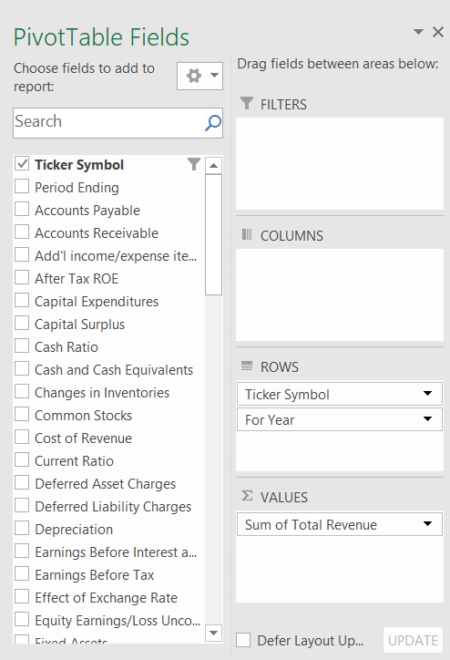**Process follow for finding the answer,**

**Result**

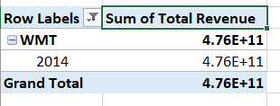

**Which company had the lowest "Earnings Per Share" in 2015?**

**Process follow for finding the answer,**

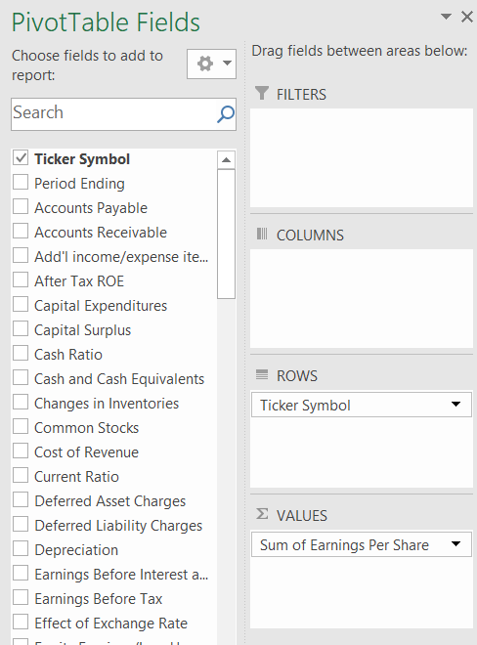

**Result**

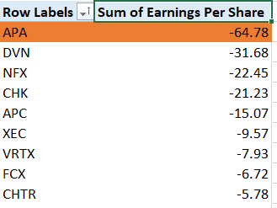

**How has the "Accounts Payable" for the company AAL changed from 2012 to 2015?**

**Process follow for finding the answer,**

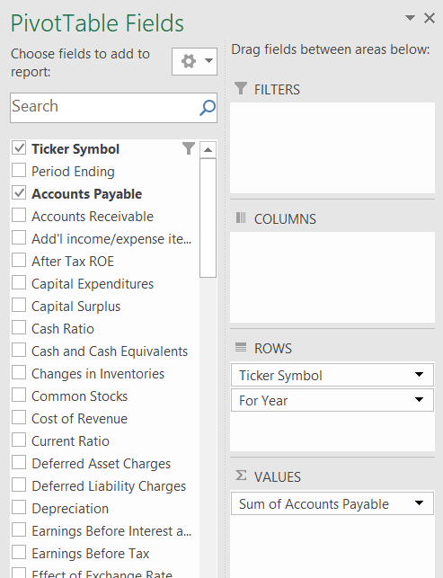

**Result**

|  |  |
| --- | --- |
| **Row Labels** | **Sum of Accounts Payable** |
| **AAL** | **17813000000** |
| 2012 | 3068000000 |
| 2013 | 4975000000 |
| 2014 | 4668000000 |
| 2015 | 5102000000 |
| **Grand Total** | **17813000000** |

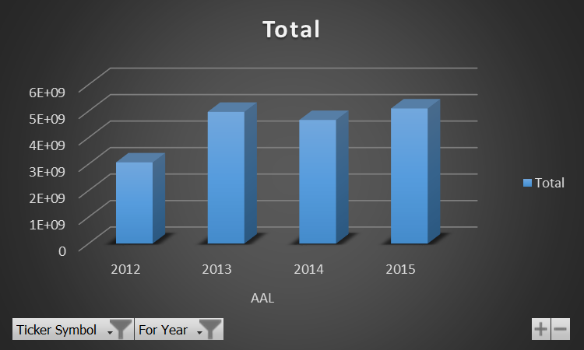

**What was the "Capital Expenditures" for AAP in 2012 and how does it compare to 2015?**

**Process follow for finding the answer,**

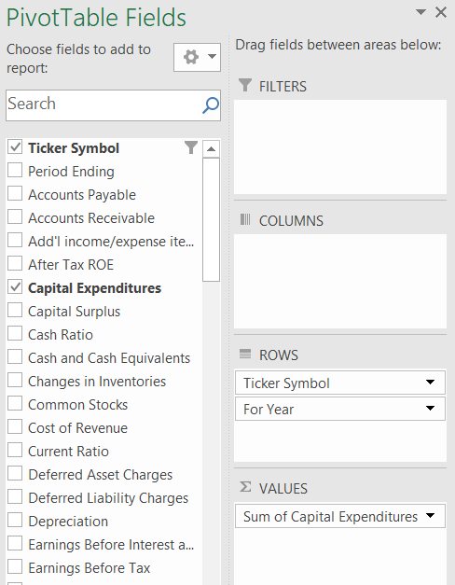

**Result**

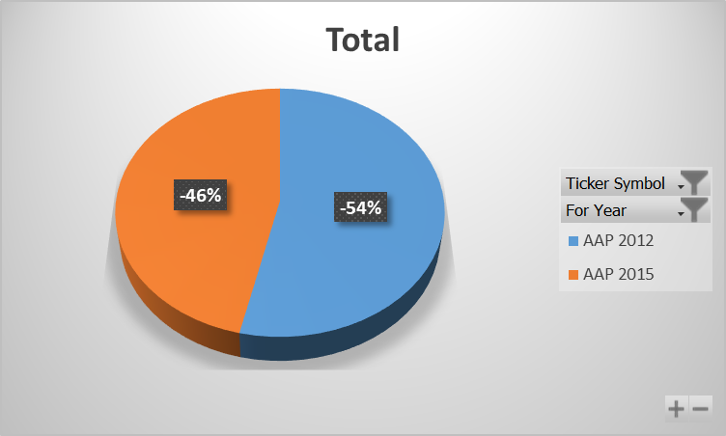

|  |  |
| --- | --- |
| **Row Labels** | **Sum of Capital Expenditures** |
| **AAP** | **-505929000** |
| 2012 | -271182000 |
| 2015 | -234747000 |
| **Grand Total** | **-505929000** |

**Which company had the highest "After Tax ROE" in 2013?**

**Process follow for finding the answer,**

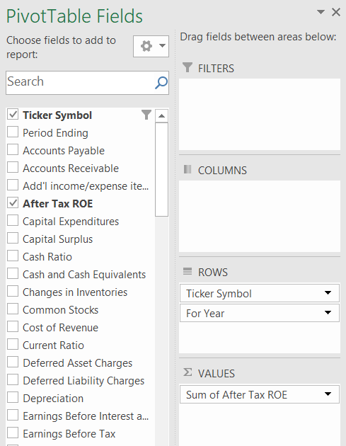

**Result**

|  |  |
| --- | --- |
| **Row Labels** | **Sum of After Tax ROE** |
| **WYNN** | **395** |
| 2013 | 395 |
| **Grand Total** | **395** |

**In which year did AAL have the largest "Total Liabilities"?**

**Process follow for finding the answer,**

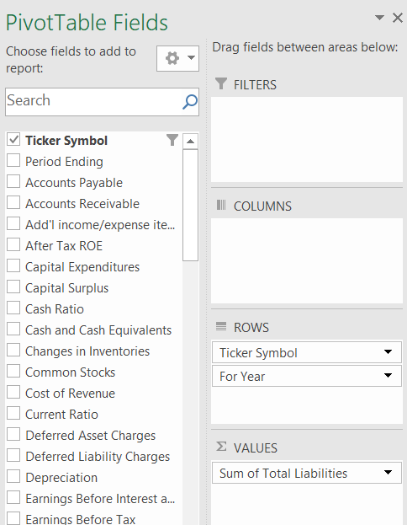

**Result**

|  |  |
| --- | --- |
| **Row Labels** | **Sum of Total Liabilities** |
| **AAL** | **1.53884E+11** |
| 2013 | 45009000000 |
| 2015 | 42780000000 |
| 2014 | 41204000000 |
| 2012 | 24891000000 |
| **Grand Total** | **1.53884E+11** |

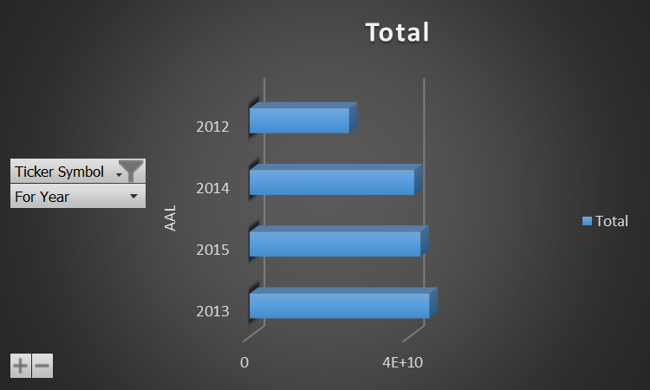

**How did the "Total Current Assets" for AAP change between 2012 and 2013?**

**Process follow for finding the answer,**

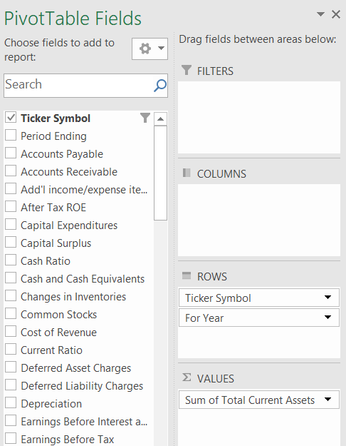

**Result**

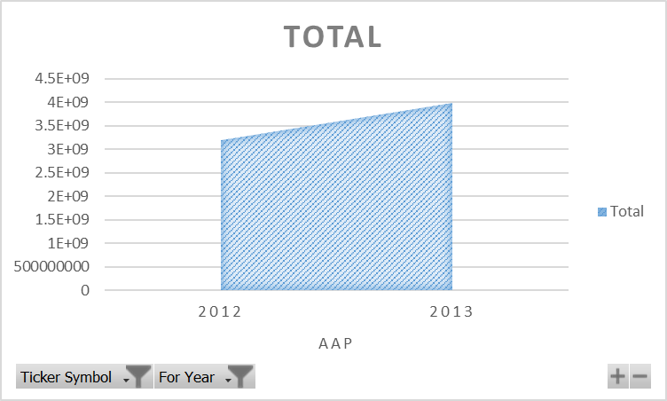

|  |  |
| --- | --- |
| **Row Labels** | **Sum of Total Current Assets** |
| **AAP** | **7173584000** |
| 2012 | 3184200000 |
| 2013 | 3989384000 |
| **Grand Total** | **7173584000** |

**Which company reported the lowest "Cash Ratio" in 2014?**

**Process follow for finding the answer,**

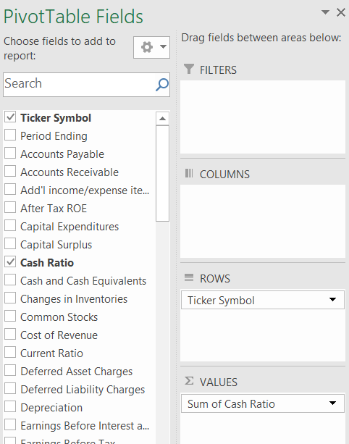

**Result**

|  |  |
| --- | --- |
| **Row Labels** | **Sum of Cash Ratio** |
| ZION | 0 |
| HUM | 0 |
| XL | 0 |
| HCP | 0 |
| HIG | 0 |
| AIG | 0 |
| AFL | 0 |
| AIZ | 0 |
| ALL | 0 |
| JPM | 0 |
| AMG | 0 |
|  |  |

**What is the difference between "Accounts Receivable" and "Accounts Payable" for AAL in 2015?**

**Process follow for finding the answer,**

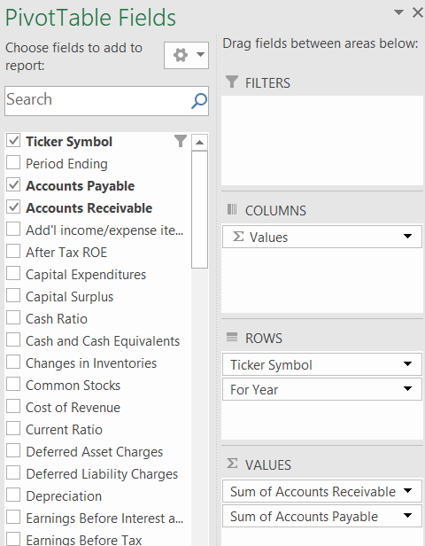

**Result**

|  |  |  |
| --- | --- | --- |
| **Row Labels** | **Sum of Accounts Receivable** | **Sum of Accounts Payable** |
| **AAL** | **352000000** | **5102000000** |
| 2015 | 352000000 | 5102000000 |
| **Grand Total** | **352000000** | **5102000000** |

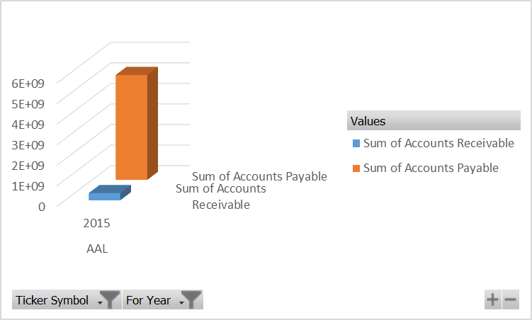

**Which year saw the highest "Capital Surplus" for AAL?**

**Process follow for finding the answer,**

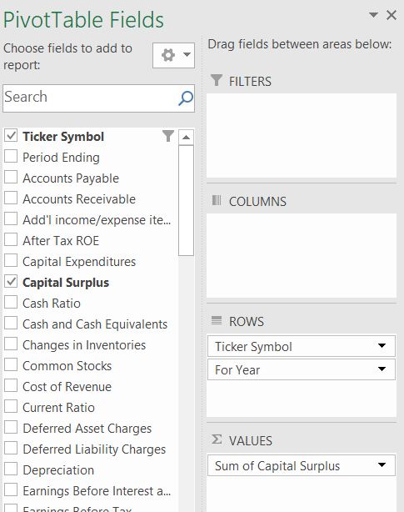

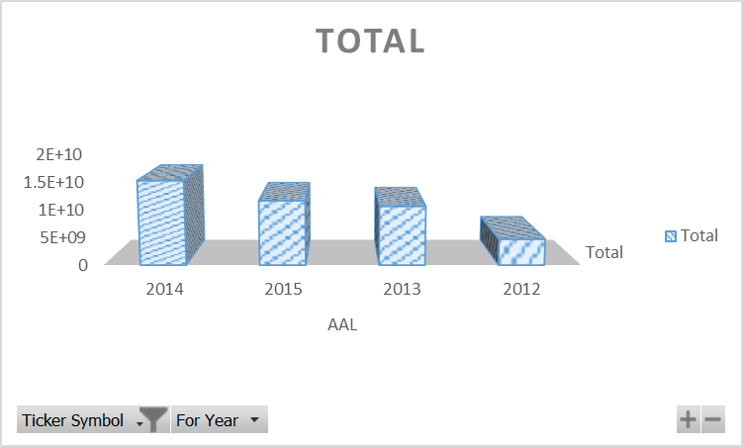**Result**

|  |  |
| --- | --- |
| **Row Labels** | **Sum of Capital Surplus** |
| **AAL** | **42013000000** |
| 2014 | 15135000000 |
| 2015 | 11591000000 |
| 2013 | 10592000000 |
| 2012 | 4695000000 |
| **Grand Total** | **42013000000** |

# **Recommendation and Conclusion**

**Based on the analysis of financial data from US publicly traded companies, the following key findings emerged:**

* **Overall financial health:** While the majority of US companies demonstrated strong financial health, there were notable variations across industries and company sizes.
* **Key financial trends:** The most prominent trends observed included increasing profitability, rising debt levels, and growing mergers and acquisitions activity.
* **Sector performance:** Technology and healthcare sectors outperformed other industries in terms of growth and profitability.
* **Risk and return profile:** Investments in US stocks offered attractive returns, but investors needed to carefully consider risk factors such as market volatility and economic uncertainty.

**Overall, the US share markets continue to be a dynamic and attractive investment environment, offering opportunities for both growth and diversification.** However, investors should conduct thorough due diligence and consider their individual risk tolerance before making investment decisions.

# **Reference list**

Garrison, R.H., Noreen, E.W. and Brewer, P.C. (2020). *Managerial accounting*. New York, Ny: Mcgraw-Hill Education.

Horngren, C.T., Datar, S.M. and Rajan, M.V. (2019). *Cost accounting: a managerial emphasis*. Uttar Pradesh, India: Pearson India Education.

Investopedia (2023). *Absorption Costing Explained, With Pros and Cons and Example*. [online] Investopedia. Available at: <https://www.investopedia.com/terms/a/absorp> tioncosting.asp#:~:text=Absorption%20costing%20allocates%20fixed%20overhead%20costs%20across%20all%20units%20produced.

Kenton, W. (2022). *Understanding cost-volume-profit – CVP analysis*. [online] Investopedia. Available at: https://www.investopedia.com/terms/c/cost-volume-profit-analysis.asp.

Kieso, D.E. and Weygandt, J.J. (2018). *Intermediate accounting*. Hoboken, Nj Wiley.

Larson, K.D. and Miller, P.B.W. (1995). *Financial accounting*. Chicago: Irwin.